Community Governance Review
Draft Recommendations
October 2026

Electoral Services, Newcastle City Council
elections@newcastle.gov.uk
Contents

1. Introduction and Statutory Criteria 2
2. Summary of Draft Recommendations 4
3. Initial Consultation 5
4. Blakelaw and North Fenham 6
5. Brunswick 9
6. Dinnington 14
7. Hazlerigg 16
8. North Gosforth 20
9. Woolsington 24
10. Conclusion 28
Appendix A – Schedule of Consultation Responses 29
Appendix B – National Association of Local Councils (NALC) Guidance on Parish Councillor Numbers 40

Introduction and Statutory Criteria
  - Newcastle City Council has resolved to undertake a Community Governance Review (CGR) of the six parished areas within Newcastle upon Tyne: Blakelaw and North Fenham, Brunswick, Dinnington, Hazlerigg, North Gosforth and Woolsington. The Review considers whether existing arrangements reflect local identities and interests, provide effective and convenient local government and take account of other arrangements for community representation and engagement.
  - The Review formally commenced on 31 July 2026 with the publication of its Terms of Reference and following agreement by the Council’s Constitutional Committee to undertake a community governance review on 27 July 2026. The Review is conducted pursuant to Section 82 of the Local Government and Public Involvement in Health Act 2007 (LGPIHA 2007), which empowers principal councils to review and make recommendations regarding community governance arrangements within their areas.
  - Prior to the commencement of the Review, the Council received submissions from Brunswick Parish Council, Hazlerigg Parish Council and North Gosforth Parish Council to amend parish boundaries following housing developments in these areas. In light of the submissions received and the period of time since community governance arrangements were last comprehensively reviewed, the Council determined that it was appropriate to examine governance arrangements across all six parished areas of the city.
  - In line with the statutory obligations set out in LGPIHA 2007, the Council consulted with residents, parish councils, elected representatives and other interested parties on existing community governance arrangements. As part of this initial consultation, the Council produced a series of preliminary proposals for each parish area to focus discussion and identify areas of change.
  - In accordance with Section 93 LGPIHA 2007, the Council has had regard to the following statutory criteria in producing its Draft Recommendations:
    - The need to secure that community governance reflects the identities and interests of the community in the area concerned;
    - The need to secure that community governance is effective and convenient; and
    - The need to take into account any other arrangements for the purposes of community representation or community engagement in the area.
  - In undertaking the Review, the Council has also considered future parish electorates, the distribution of electors, likely future changes and indicative guidance produced by the National Association of Local Councils (NALC) on parish councillor numbers. The NALC guidance has been reproduced in Appendix B. Such guidance is not prescriptive however and local circumstances and evidence from consultation remain relevant.
  - These Draft Recommendations do not represent the Council's final decisions. They set out the Council's provisional conclusions following assessment of the evidence gathered during the Review to date. Consultees are encouraged to comment on the Recommendations, supporting evidence and reasoning contained within this document. All representations received will be carefully considered before the Council determines its Final Recommendations and any consequential changes to community governance arrangements.

Summary of Draft Recommendations
  - The Council's Draft Recommendations are summarised below and are explained in greater detail throughout the remainder of this document.

Parish area | Recommendation
Blakelaw and North Fenham | No change to existing community governance arrangements.
Brunswick | Transfer Havannah Park development and associated land north of Coach Lane to Hazlerigg.
Dinnington | No change to existing community governance arrangements.
Hazlerigg | Receive Havannah Park development and associated land from Brunswick; adjust the southern boundary to align with polling districts to remove properties on Aspenwood Grove, Elmwood Park Gardens and Oakwood Drive.
North Gosforth | Include the remainder of the North Gosforth Park development, remove one property on McCracken Close and increase the number of parish councillors from 10 to 12.
Woolsington | Retain existing parish boundaries and ward boundaries, with no changes beyond the electoral changes already due to take effect in May 2027; increase the council from 12 to 15 councillors and revise parish ward allocations.

Initial Consultation
  - The first stage of consultation was undertaken between 14 August 2026 and 28 September 2026.
  - Consultees could respond through the Council’s designated online consultation platform, ‘Let’s Talk Newcastle’, as well as by email, telephone or in writing. Members of the Electoral Services team also attended parish council meetings in five of the six parishes during the consultation period. Notes of those discussions were retained and have been taken into account in preparing the Draft Recommendations.
  - There were 15 responses received to the first stage of public consultation, all of which are available to view in Appendix A (subject to relevant redactions). Of the 15 responses, seven responses came from residents and eight from parish councils or councillors.
  - No representations were received with regard to proposals concerning Dinnington.
  - The majority of respondents broadly supported the preliminary proposals published by the Council prior to the first stage of consultation.
  - Suggestions were made during consultation at Blakelaw and North Fenham Community Council’s meeting that the external parish boundary of Blakelaw and North Fenham Parish could be extended. Blakelaw and North Fenham Community Council subsequently confirmed that it did not support such changes.
  - A Brunswick resident submitted a comprehensive response that disagreed with the Council’s proposals and emphasised the potential impact of reducing the parish tax base on the ability of the parish council to deliver effective and convenient governance.
  - Hazlerigg Parish Council raised queries regarding the future governance arrangements for the allotments situated north of Coach Lane. Following further discussion, the Parish Council confirmed its support for the Council's proposed boundary changes.
  - Woolsington Parish Council submitted comments regarding parish councillor numbers and electoral arrangements. Residents in Woolsington also raised concerns regarding the impact of the Review on existing community initiatives in the parish.
  - A detailed assessment of the representations received is provided within the relevant parish sections of this document.

Blakelaw and North Fenham
  - Current Arrangements and Background
    - Blakelaw and North Fenham comprises the area shown on Figure 1 and forms one of the six parished areas within Newcastle upon Tyne.
    - The parish currently has an electorate of 4,763. It is divided into three parish wards: Blakelaw, Cragston and North Fenham. Blakelaw parish ward has 2,742 electors, Cragston parish ward has 1,193 electors and North Fenham parish ward has 828 electors.
    - The Community Council is represented by 12 community councillors. Blakelaw parish ward is represented by six community councillors, Cragston parish ward is represented by three community councillors and North Fenham parish Ward is represented by three community councillors. There are currently five vacancies on the Community Council. There is one vacancy in Blakelaw and two vacancies respectively for Cragston and North Fenham.
    - The Council’s preliminary proposals stated that no change was necessary although consideration should be given to the number of vacancies currently on the Community Council. Also identified was the need to conduct a separate statutory polling district and polling place review to ensure the parish ward boundaries align with polling district boundaries.
  - Consultation Responses
    - Three representations were received in relation to the parish of Blakelaw and North Fenham.
    - Electoral Services attended Blakelaw and North Fenham Community Council’s meeting on 14 September 2026. Discussion focused on whether extending the parish boundary would help encourage greater participation and address the historic vacancies on the Community Council. Following these discussions, the Community Council did subsequently submit a written response and agreed to not extend the external parish boundaries. It also indicated it would be willing to consider a reduction in the number of community councillors.
    - A resident responded through the Let’s Talk Newcastle platform agreeing with the Council’s proposals submitted at the start of the consultation.
    - A community councillor responding through the Let's Talk Newcastle platform raised concerns regarding restrictions on the level of grant funding that may be awarded to community groups and the potential impact on local organisations. Whilst the comment has been noted as part of the consultation process, it does not relate directly to community governance arrangements within the scope of the Review. Any changes to community grant funding arrangements would be a matter for the Community Council itself to determine and do not form part of the Draft Recommendations.
    - Overall, the representations received did not identify any substantive concerns regarding community governance arrangements.
  - Draft Recommendation
    - The Council proposes that no changes be made to the existing community governance arrangements of the parish of Blakelaw and North Fenham.
    - The Council considers that the existing arrangements continue to:
      - reflect the identities and interests of the local community;
      - provide effective and convenient local government; and
      - support appropriate community representation and engagement.
  - Assessment
    - The Council has considered whether existing community governance arrangements continue to reflect the identities and interests of the community in Blakelaw and North Fenham.
    - The Council notes that no substantive proposals were received seeking changes to the parish boundary and no evidence was presented during consultation to suggest that the current arrangements fail to reflect local identities or interests. Whilst discussions were raised regarding extending the parish boundary, these discussions were preliminary in nature and did not result in a definitive proposal or identify a clear case for change. The Council considers that the existing parish boundary remains readily identifiable and continues to provide an appropriate basis for community representation.
    - The Council has considered whether the existing arrangements continue to provide effective and convenient local government.
    - As part of the consultation, the Council invited views on whether the current number of councillors remained appropriate, particularly in light of a number of long-standing vacancies. Whilst the Community Council indicated that it would not oppose a reduction in councillor numbers, the Council is not ultimately persuaded that the existence of vacancies alone justifies a change to the current electoral arrangements. Indeed, vacancies are not uncommon in parish and community councils and may reflect challenges in recruiting candidates rather than indicating that existing arrangements are inappropriate. The Council also notes that the current councillor allocation remains broadly consistent with the guidance issued by NALC and continues to provide flexibility for future recruitment and community representation. The Council therefore considers that the existing arrangements remain effective and convenient and that there is insufficient justification for altering the current councillor allocation.
    - The Council has also had regard to existing arrangements for community representation and engagement within the parish and considers that Blakelaw and North Fenham Community Council continues to provide a mechanism for local democratic representation and community engagement within the parish area.

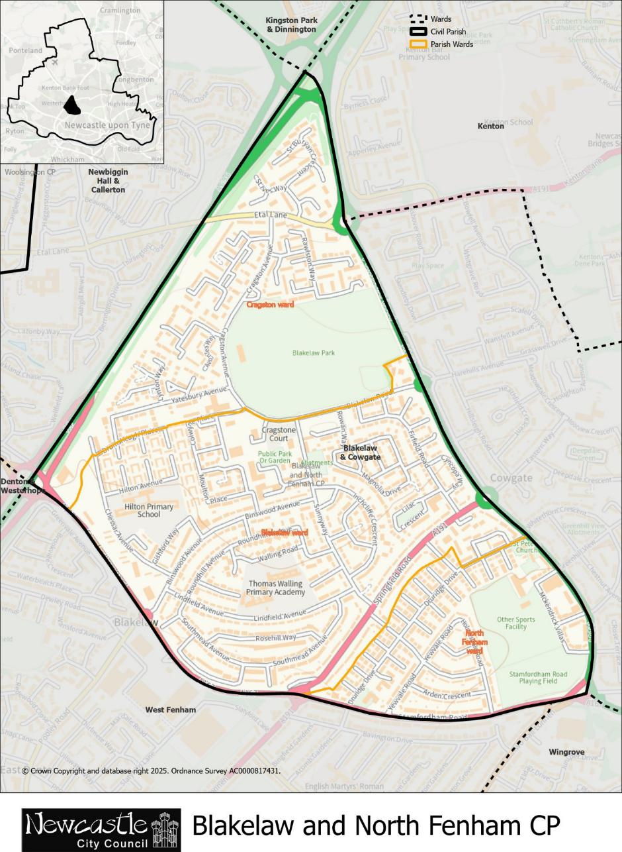

Figure 1 - Map of the current parish of Blakelaw and North Fenham

Brunswick
  - Current Arrangements and Background
    - Brunswick comprises the area shown on Figure 2 and forms one of the six parished areas within Newcastle upon Tyne.
    - The parish currently has an electorate of 1,500. It is not divided into parish wards.
    - The Parish Council is represented by six parish councillors. There are currently no vacancies.
    - Brunswick Parish Council submitted a joint proposal with Hazlerigg Parish Council to undertake a community governance review of the parish boundaries in September 2019. The Council’s Constitutional Committee did agree in October 2019 that a community governance review could be undertaken. Whilst the review was not progressed further at that time, the issues raised have subsequently been reconsidered as part of the present Review.
    - The Council’s preliminary proposals stated that the external parish boundary should be amended in accordance with the joint submission by Brunswick Parish Council and Hazlerigg Parish Council. Specifically, that the southern parish boundary should be amended to transfer the Havannah Park development from the parish of Brunswick to the parish of Hazlerigg.
  - Consultation Responses
    - Two representations were received in relation to the parish of Brunswick.
    - Electoral Services attended Brunswick Parish Council’s meeting on 9 September 2026. Parish councillors were in agreement with the Council’s proposals. The Parish Council subsequently submitted a written response confirming its support for the Council’s proposals.
    - A resident submitted a detailed response by email and through the Let's Talk Newcastle platform. The response did not support the proposed transfer of the Havannah Park development arguing that it could have financial and governance implications in substantially reducing the electorate size – and thereby the corresponding tax base – and could weaken its sense of community identity and ability to function as a distinct and sustainable parish. The response highlighted that the Council should consider alternative arrangements as well as the possibility of a staged approach to assess the effectiveness of the proposed boundary changes. The Council notes the response’s detailed commentary on the potential negative impact on the effectiveness and convenience of local government, however, particular concerns regarding the level of parish precept would be determined by the Parish Council and do not fall within the scope of the Council's powers through a Community Governance Review.
  - Draft Recommendation
    - The Council recommends that the external parish boundary should be amended in accordance with the map detailed in Figure 3. This would change the southern parish boundary line and transfer the Havannah Park development and associated land north of Coach Lane to the parish of Hazlerigg.
    - The streets proposed to transfer to Hazlerigg comprise Collier Gardens, Corver Crescent, Dataller Drive, Stoneman Court and Winder Drive, affecting approximately 798 electors. This would reduce the electorate of Brunswick from 1,500 electors to 702 electors.
    - It is recommended that these changes are to be implemented with effect from the next ordinary parish elections in May 2027.
    - The Council notes that implementation of the recommendation may require a subsequent statutory review of polling districts and polling places to ensure consistency between parish and electoral boundaries. Such matters would be considered separately and do not form part of this Review.
  - Assessment
    - The Council has considered whether existing community governance arrangements continue to reflect the identities and interests of the community in Brunswick.
    - It is noted that the Havannah Park development forms a distinct residential area located to the north of Coach Lane and is separated from the remainder of Brunswick. Furthermore, the Council acknowledges that access to and from the development is primarily through Hazlerigg and that residents share close links with the facilities, services and community infrastructure located within Hazlerigg. Evidence of those established connections can be seen in the use of the playing field adjacent to the development by Hazlerigg Football Club, despite the site currently being situated within Brunswick.
    - The Council further notes that the proposal originates from Brunswick Parish Council and Hazlerigg Parish Council both of which have consistently supported the transfer of the development since at least 2019.
    - Whilst a resident objected to the proposal, the Council notes that the objection primarily focused on the implications of the boundary change for effective and convenient local government rather than the separate statutory test of whether the proposal would better reflect community identity and interests. The Council also notes the suggestion of a phased approach by the respondent. However, the purpose of a community governance review is to determine the appropriate long-term governance arrangements for an area. There is no provision within the review process for temporary or trial arrangements pending a future assessment as recommendations need to be assessed as lasting changes.
    - The Council therefore considers that the proposed boundary amendment would better reflect local community identity and interests than the existing arrangements.
    - The Council has considered whether the proposed boundary amendment would secure effective and convenient local government.
    - The Council acknowledges the concerns raised during consultation regarding the reduction in electorate size. In particular, issues were raised regarding the potential impact on parish finances and precept levels as a significant reduction in the electorate, and the corresponding tax base, could create financial and budgetary pressures for the Parish Council. That is, if expenditure remained unchanged, a smaller tax base could place upward pressure on the precept paid per household.
    - Nevertheless, decisions relating to a parish council’s budget, expenditure and precept are matters for the Parish Council itself and cannot be determined through this Review. Whilst the potential impact of changes to the tax base may be considered as part of an assessment of effective and convenient local government, it is not in itself determinative and must be appropriately weighed against other statutory criteria. Furthermore, detailed financial modelling of the future position of the Parish Council would require assumptions regarding future levels of expenditure, service provision and precept setting that fall outside the scope of this Review.
    - Discussion at Brunswick’s Parish Council meeting highlighted that Brunswick Parish Council functioned effectively prior to the construction and occupation of the Havannah Park development. Whilst the recommended transfer would reduce the parish electorate and tax base, the evidence does not suggest that the Parish Council would be unable to continue operating effectively following a return to a smaller electorate more closely aligned with its historic size.
    - The Council further notes that Brunswick Parish Council currently has a full complement of councillors and that no concerns were raised during consultation regarding the Parish Council's ability to conduct its business or represent the community effectively.
    - Having considered the representations received, the Council is satisfied that the recommended boundary amendment would continue to secure effective and convenient local government and that the concerns raised do not outweigh the community identity and representation benefits arising from the proposal.
    - The Council has considered whether there are any other arrangements for community representation or community engagement within the area which should be taken into account.
    - Residents within both Brunswick and the Havannah Park development currently benefit from parish-level representation and mechanisms for local engagement. No alternative arrangements for community representation were identified during consultation which would materially affect the assessment of the recommendations.
    - Guidance does state that particular care should be taken when considering alternative governance arrangements for smaller parishes and whether the existence of a parish council is justified. However, there is no evidence to suggest that the Parish Council is unable to operate effectively or that alternative governance arrangements would be more suitable.

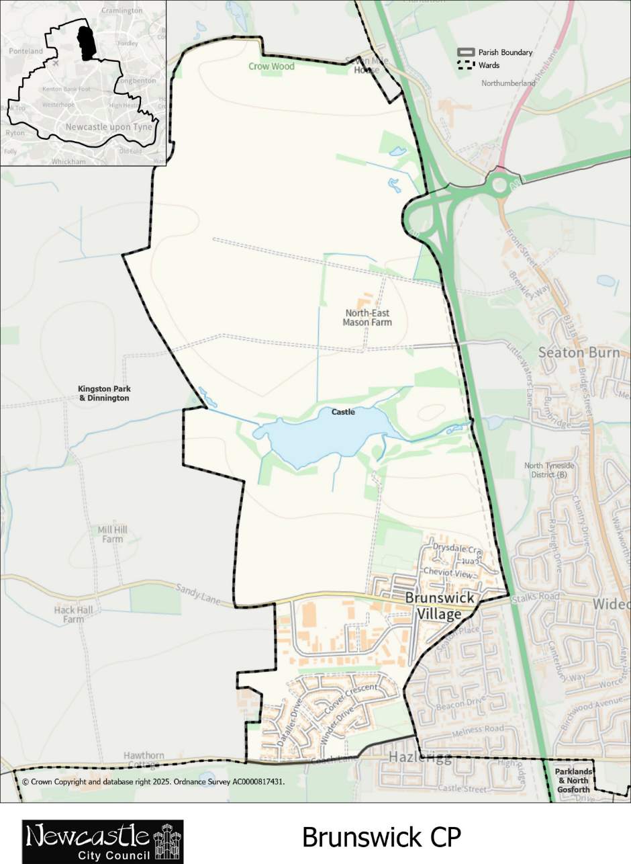

Figure 2 - Map of the current parish of Brunswick

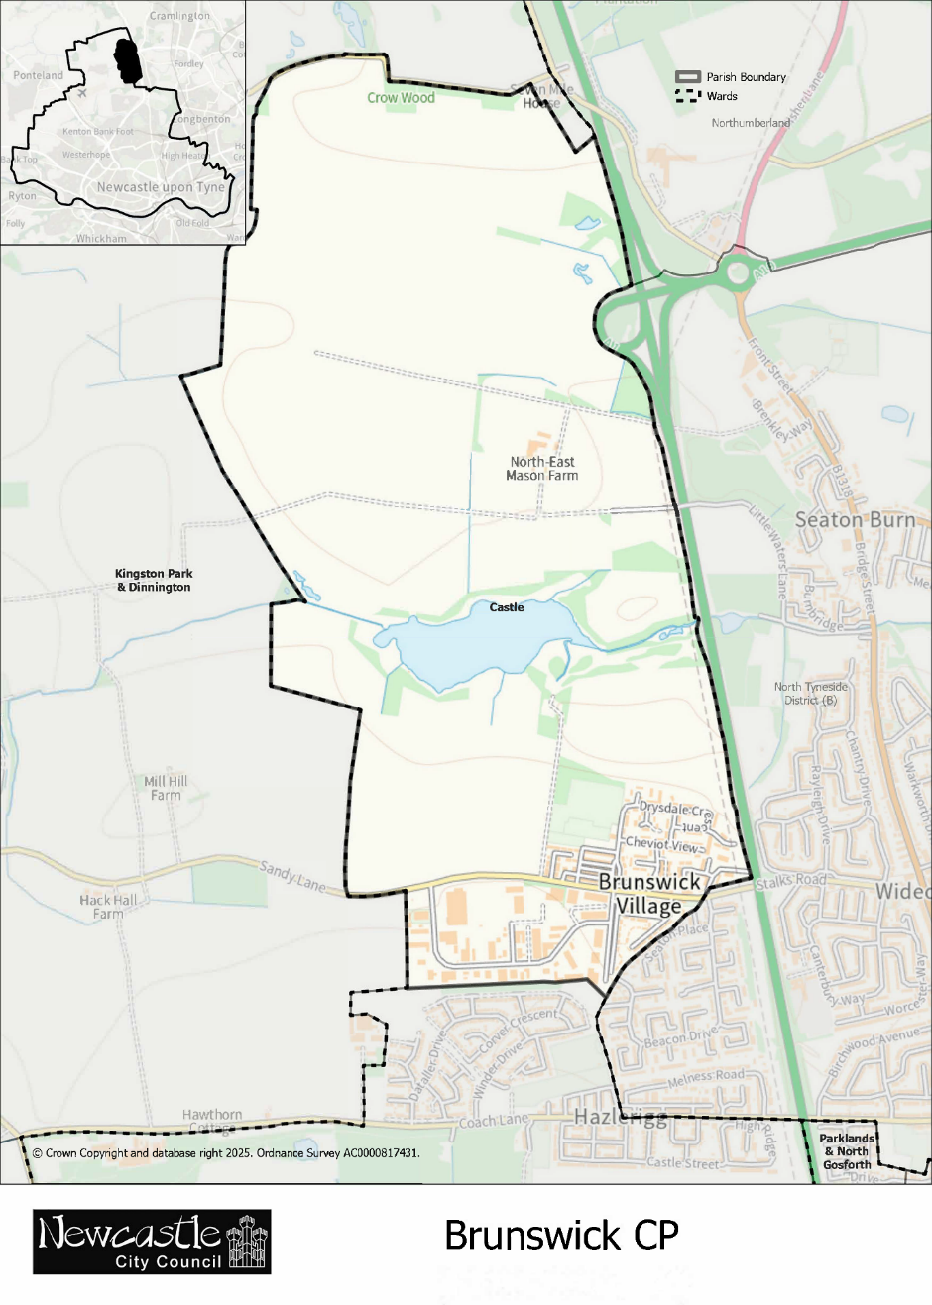
Figure 3 - Map of the recommended boundaries for the parish of Brunswick

Dinnington
  - Current Arrangements and Background
    - Dinnington comprises the area shown on Figure 4 and forms one of the six parished areas within Newcastle upon Tyne.
    - The parish currently has an electorate of 1,963. It is not divided into parish wards.
    - The Parish Council is represented by 10 parish councillors. There are currently no vacancies on the Parish Council.
    - The Council’s preliminary proposals stated that no change to existing community governance arrangements was necessary.
  - Consultation Responses
    - No representations were received in relation to the parish of Dinnington. In the absence of evidence from consultation, the Council has had regard to the existing statutory criteria in assessing scope for any possible change.
  - Draft Recommendation
    - The Council proposes that no changes be made to the existing community governance arrangements of the parish of Dinnington.
    - The Council considers that the existing arrangements continue to:
      - reflect the identities and interests of the local community;
      - provide effective and convenient local government; and
      - support appropriate community representation and engagement.
  - Assessment
    - The Council has considered whether existing community governance arrangements continue to reflect the identities and interests of the community in Dinnington. As no proposals were received, there is no evidence to suggest that existing arrangements require amendment and reaffirm that the existing parish boundaries provide an appropriate basis for community identity.
    - The Council also notes that the current councillor allocation remains broadly consistent with the guidance issued by NALC and continues to provide flexibility for future recruitment and community representation. The Council therefore considers that the existing arrangements remain effective and convenient and that there is insufficient justification for altering the current councillor allocation. Having regard to community representation, the Council considers that current arrangements provide appropriate avenues for community representation and engagement.

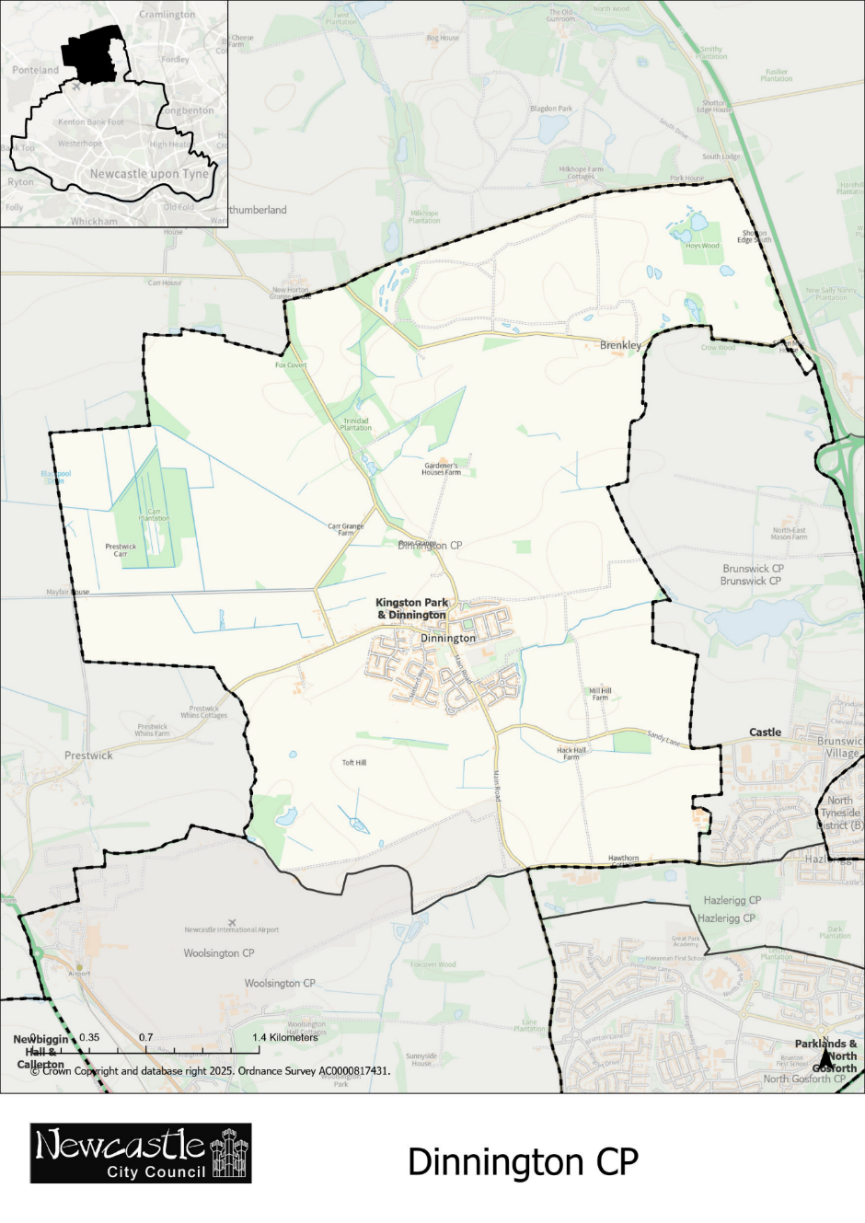
Figure 4 - Map of the current parish of Dinnington

Hazlerigg
  - Current Arrangements and Background
    - Hazlerigg comprises the area shown on Figure 5 and forms one of the six parished areas within Newcastle upon Tyne.
    - The parish currently has an electorate of 657. It is not divided into parish wards.
    - The Parish Council is represented by eight parish councillors. There are currently three vacancies.
    - Hazlerigg Parish Council submitted a joint proposal with Brunswick Parish Council to undertake a community governance review of the parish boundaries in September 2019. The Council’s Constitutional Committee did agree in October 2019 that a community governance review could be undertaken. Whilst the review was not progressed further at that time, the issues raised have subsequently been reconsidered as part of the present Review.
    - The Council’s preliminary proposals stated that the external parish boundary should be amended in accordance with the joint submission by Brunswick and Hazlerigg Parish Councils. Specifically, that the northern parish boundary of Hazlerigg should be amended to transfer the Havannah Park development from the parish of Brunswick to the parish of Hazlerigg.
    - Further to this, the Council proposed an amendment to the southern parish boundary to align the parish boundary with the existing polling district boundary between polling district E02 and E03. The proposals also referenced the historic vacancies in the parish as well as the potential impact of the planned Brunton Quarry Park development.
  - Consultation Responses
    - Two representations were received in relation to the parish of Hazlerigg.
    - Electoral Services attended Hazlerigg Parish Council’s meeting on 30 July 2026. Parish councillors were notified of the commencement of the Review and the proposed transfer of the Havannah Park development to Hazlerigg in line with the proposals set out in the joint submission by Brunswick and Hazlerigg Parish Councils.
    - A representation was submitted by a Hazlerigg parish councillor expressing concern regarding the proposed transfer of the allotment site situated north of Coach Lane. The respondent noted existing management issues associated with the allotments and questioned whether responsibility for the site should transfer to Hazlerigg as part of the wider boundary amendment.
    - Following further consideration, Hazlerigg Parish Council submitted a formal response confirming its support for the Council's proposals, including the proposed transfer of the Havannah Park development and associated land.
  - Draft Recommendation
    - The Council recommends that the external parish boundary should be amended in accordance with the map detailed in Figure 6. This would change the northern parish boundary line and transfer the Havannah Park development and associated land north of Coach Lane to the parish of Hazlerigg. It would also adjust the southern parish boundary line to bring the parish boundary into coterminosity with the existing polling district line.
    - The streets proposed to transfer to Hazlerigg comprise Collier Gardens, Corver Crescent, Dataller Drive, Stoneman Court and Winder Drive, affecting approximately 798 electors.
    - Nine properties from Aspenwood Grove, Elmwood Park Gardens and Oakwood Drive would be removed from the parish as part of the Council’s recommendations, affecting approximately 19 electors. Including the recommended transfer of Havannah Park, the electorate size for Hazlerigg would increase to approximately 1,455.
    - It is recommended that these changes are to be implemented with effect from the next ordinary parish elections in May 2027.
    - The Council notes that implementation of the recommendation may require a subsequent statutory review of polling districts and polling places to ensure consistency between parish and electoral boundaries. Such matters would be considered separately and do not form part of this Review.
  - Assessment
    - Having regard to the evidence received during consultation, the Council considers that the proposed transfer of the Havannah Park development from Brunswick to Hazlerigg would better reflect the identities and interests of the community.
    - It is noted that the Havannah Park development forms a distinct residential area located to the north of Coach Lane. Access to and from the development is primarily through Hazlerigg and the Council acknowledges that residents share close links with the facilities and services in Hazlerigg. Further discussions with local residents at Hazlerigg’s Parish Council meeting also indicated that many residents identify more closely with Hazlerigg and were unaware that the area currently falls within Brunswick.
    - The Council further notes that the proposal originates from Brunswick Parish Council and Hazlerigg Parish Council both of which have consistently supported the transfer of the development since at least 2019.
    - No representations were received opposing the proposed amendment to the southern parish boundary. Unlike the Havannah Park development, the affected properties on the southern boundary form part of the wider Great Park development area and do not have established ties with Hazlerigg. As the existing parish boundary currently passes through the development, neighbouring properties within the same streets are subject to different governance arrangements. The proposed amendments would consequently support greater community cohesion and are considered to better reflect the community identity in the area.
    - Regarding the proposed Brunton Quarry Park development, no representations were received in relation to this matter. The proposed development has not yet commenced and remains subject to relevant planning approvals and, at the present time, the Council considers no amendment necessary. Nevertheless, the scale of proposed development may have implications for community governance arrangements in the future and may warrant further consideration once the development has more substantively progressed.
    - The Council has considered whether the proposed changes would secure effective and convenient local governance.
    - Among the Council’s proposals, it was suggested that the number of councillors for Hazlerigg Parish Council should be reduced to address long-standing vacancies. Upon further consideration, the Council is not satisfied that reducing the number of councillors is appropriate. The proposed boundary amendments would increase the parish electorate and bring Hazlerigg into line with the NALC guidance for a council of eight members. Retaining the existing councillor allocation would provide capacity for this future growth and ensure continued effective community representation.
    - Inclusion of the allotment site, playing field and pavilion within the proposed transfer area is also considered to support effective and convenient local government. Although concerns were raised in consultation regarding the allotment site in particular, the Council does not recognise that their inclusion within Hazlerigg would necessarily undermine the effectiveness and convenience of local government. Indeed, these facilities are situated very closely to the Havannah Park development and their transfer to Hazlerigg would avoid the creation of a fragmented parish boundary whereby community facilities fall within separate parishes.
    - As such, the Council concludes that the recommended changes would help secure effective and convenient local government.
    - The Council has had regard to other arrangements for community representation or community engagement within the area and is satisfied that the recommended changes are appropriate and provide effective mechanisms for community representation and engagement.

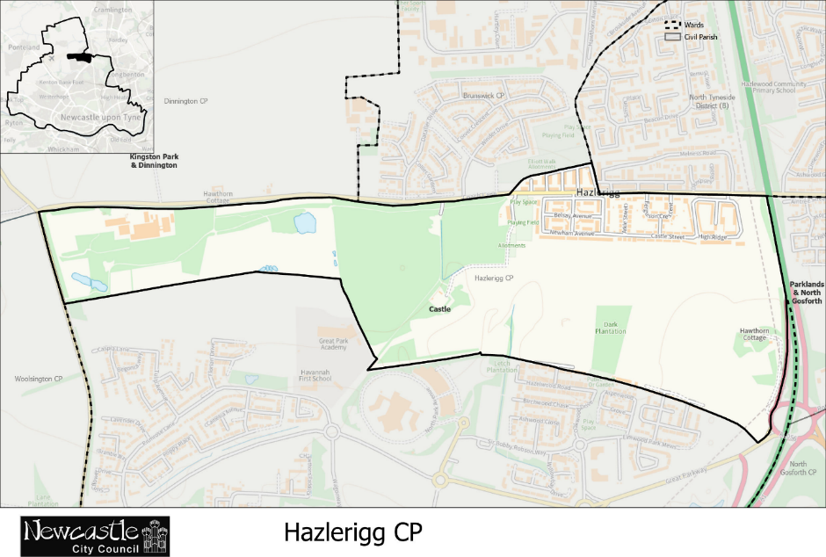

Figure 5 - Map of the current parish of Hazlerigg
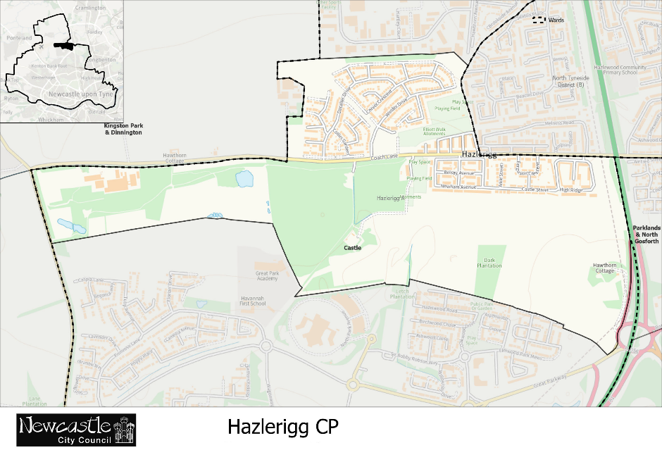
Figure 6 - Map of the recommended boundaries for the parish of Hazlerigg

North Gosforth
  - Current Arrangements and Background
    - North Gosforth comprises the area shown on Figure 7 and forms one of the six parished areas within Newcastle upon Tyne.
    - The parish currently has an electorate of 4,362. It is not divided into parish wards.
    - The Parish Council is represented by 10 parish councillors. There is currently one vacancy on the Parish Council.
    - North Gosforth Parish Council submitted a proposal in 2021 to extend the parish boundary in the northwest to incorporate the entirety of the North Gosforth Park development, situated south of Coach Lane, within the parish. The current parish boundary runs through the centre of the development, leaving a number of properties outside the parish. The submission also proposed an increase in the number of councillors to reflect the anticipated increase in electorate arising from the redefined parish area.
    - The Council’s preliminary proposals stated that the external parish boundary to the northwest should be amended in accordance with the submission by North Gosforth Parish Council. Also identified was the need to adjust the southern parish boundary to remove one property on McCracken Close.
  - Consultation Responses
    - Two representations were received in relation to the parish of North Gosforth.
    - Electoral Services attended North Gosforth Parish Council’s meeting on 16 September 2026. Officers presented the Council’s proposals and took questions. Parish councillors were in agreement with the Council’s proposals.
    - North Gosforth Parish Council subsequently submitted a written response formally agreeing with the Council’s proposals.
    - A resident responded through the Let’s Talk Newcastle platform agreeing with the Council’s proposals.
  - Draft Recommendation
    - The Council recommends that the external parish boundary should be amended in accordance with the map detailed in Figure 8. This would amend the northwestern external boundary to include the entirety of the North Gosforth Park development. The southern boundary has also been amended to remove one property on McCracken Close and bring the boundary into coterminosity with polling district boundaries.
    - The streets recommended to transfer to North Gosforth comprise Aintree Street, Chepstow Close, Cheltenham Close, Newmarket Close and Ascot Drive (part of), affecting approximately 231 electors. Factoring in the changes on McCracken Close, the overall parish electorate would increase from 4,362 to 4,592. These changes would help better reflect the identities and interests of the community.
    - Further changes are recommended to increase the number of councillors on the Parish Council from the existing 10 councillors to 12 councillors.
    - It is recommended that these changes are to be implemented with effect from the next ordinary parish elections in May 2027.
    - It is noted that implementation of the recommendation may require a subsequent review of polling districts and polling places to ensure consistency between parish and electoral boundaries. Such matters would be considered separately and do not form part of this Review.
  - Assessment
    - Further to the statutory criteria, consideration has been given to how community governance in the area reflects the identities and interests of the community.
    - The Council considers that the existing boundaries are not necessarily reflective of community identity and interests. The boundary line in question was established before the North Gosforth Park development was constructed and now divides a single residential community across two different areas. Residents living within the same development, and in some cases the same street, are therefore subject to different community governance arrangements despite sharing the same neighbourhood, facilities and community interests. Amending the parish boundary would improve community cohesion and is considered to better reflect the community identity in the area.
    - North Gosforth Parish Council has consistently supported the inclusion of the development and originally submitted a proposal to that effect in 2021.
    - In addition, the recommended removal of the property on McCracken Close would further improve boundary coherence and better reflect community identity. The current arrangement results in an anomalous, isolated property being governed differently from properties on the same street.
    - The Council has also had regard to the effectiveness and convenience of local governance.
    - The Parish Council's submission raised the possibility of increasing the number of councillors in line with the increase in electorate. It is considered that the number of councillors should be increased to bring the councillor allocation more closely into line with the indicative ranges published by NALC. Whilst the current composition of 10 councillors may provide effective and convenient governance, the existing and projected electorate is greater than that ordinarily associated with a council of that size. Increasing the number of councillors to 12 would thus strengthen the effectiveness and convenience of local governance by improving the ratio of electors to councillors and ensuring that the Parish Council has sufficient capacity to represent the interests of residents. It is noted however that the Parish Council is currently carrying a vacancy and any improvements would be subject to councillor recruitment.
    - The Council has had regard to other arrangements for community representation within the area and is satisfied that the recommended changes are appropriate and provide effective mechanisms for representation and engagement.

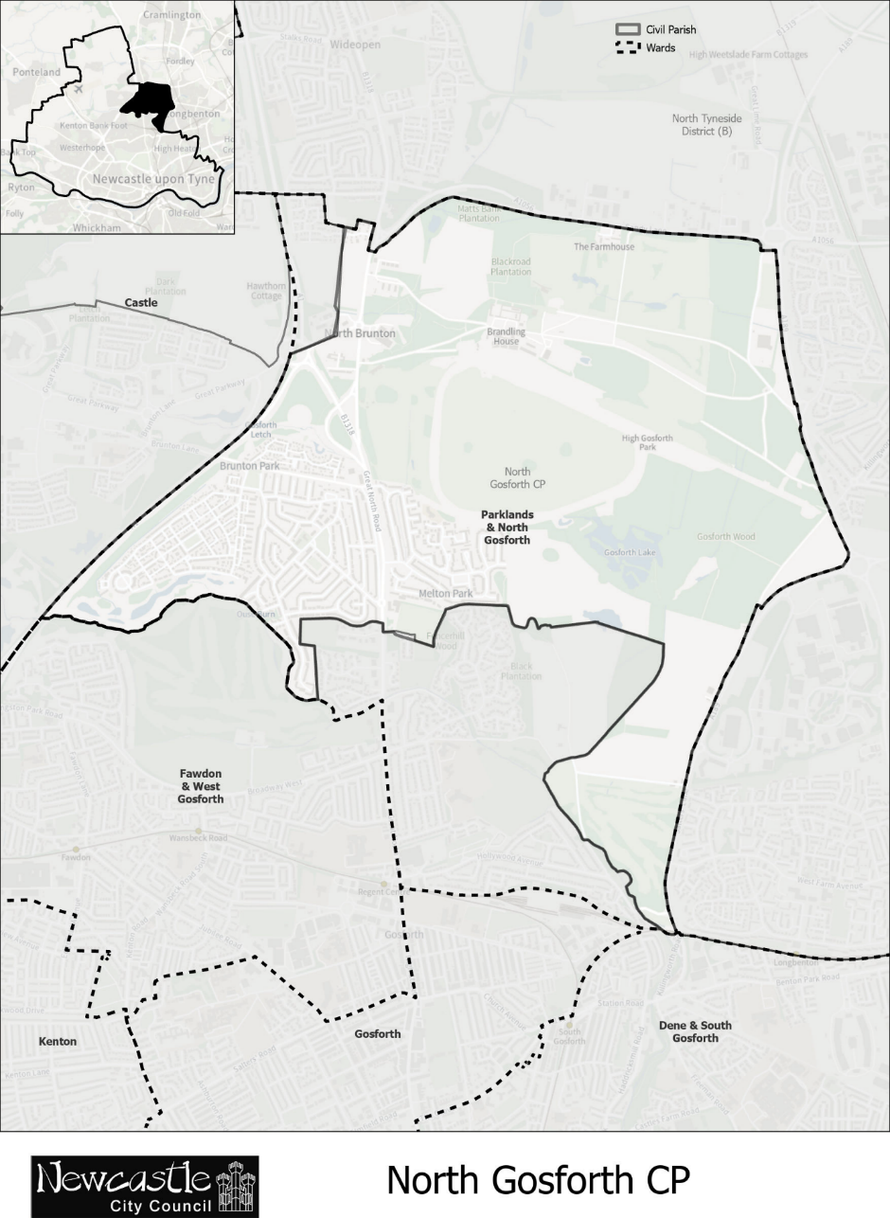

Figure 7 - Map of the current parish of North Gosforth

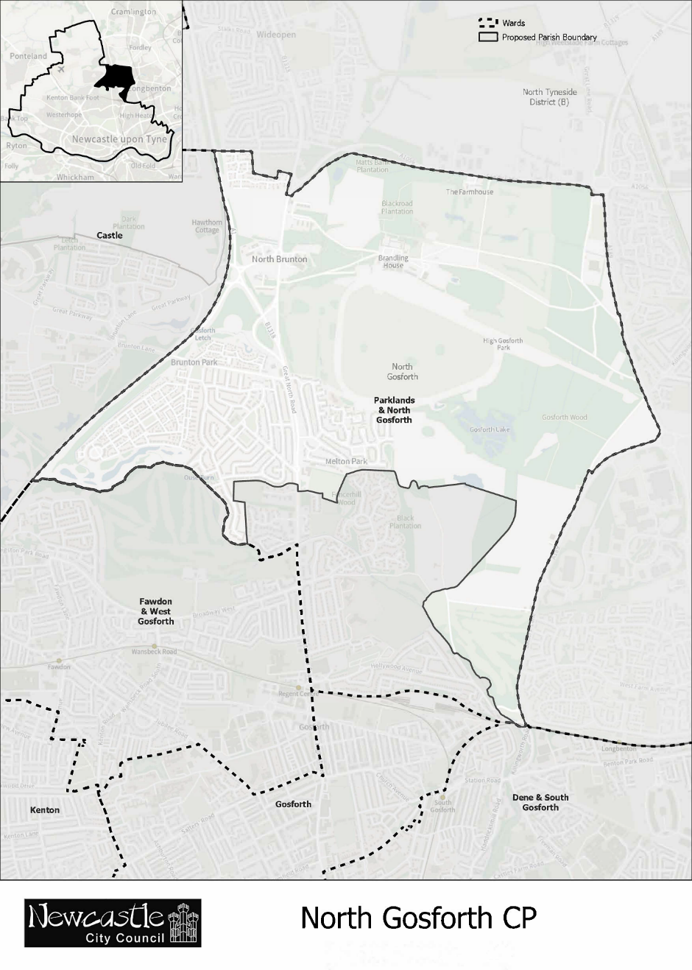
Figure 8 - Map of the recommended boundaries for the parish of North Gosforth

Woolsington
  - Current Arrangements and Background
    - Woolsington comprises the area shown on Figure 9 and forms one of the six parished areas within Newcastle upon Tyne.
    - The parish currently has a total electorate of 7,707. It is divided into four parish wards: Bedeburn (1,598 electors), Callerton (1,949 electors), Newbiggin Hall (2,568 electors) and Woolsington & Bank Foot (1,592 electors).
    - Woolsington Parish Council is represented by 12 parish councillors. There are currently no vacancies.
    - The Council did complete a community governance review in Woolsington in 2018.
    - Following the Local Government Boundary Commission for England's (LGBCE) electoral review, which was implemented by the Newcastle upon Tyne (Electoral Changes) Order 2025, changes were made to the boundaries of Callerton parish ward and Woolsington & Bank Foot parish ward. As a result, a small number of properties south of the A696 were transferred from Woolsington & Bank Foot to Callerton. These changes will take effect for ordinary parish elections in May 2027.
    - The LGBCE recommended consequential changes to the number of councillors as follows: Bedeburn (3 councillors), Callerton (2 councillors), Newbiggin Hall (4 councillors) and Woolsington & Bank Foot (3 councillors).
    - The Council’s preliminary proposals stated that no change to existing community governance arrangements was necessary beyond the changes already implemented through the 2025 Electoral Changes Order. Reference was also made in the proposal document to major new developments in the area, namely the Upper Callerton and Brunton Lane developments and the potential impact of these developments to the electorate.
  - Consultation Responses
    - Six representations were received in relation to the parish of Woolsington.
    - Electoral Services attended Woolsington Parish Council's meeting on 16 September 2026. Discussion focused on the scope of the Community Governance Review, the impact of changes arising from the LGBCE electoral review and the future governance arrangements of the parish. Officers clarified the purpose of the Community Governance Review and confirmed that no proposals had been put forward to substantially alter the governance arrangements for Woolsington. Parish councillors also questioned whether the suggested councillor allocation continues to provide the most appropriate level of representation and suggested that this should be reconsidered.
    - A parish councillor writing on behalf of Woolsington Parish Council submitted a detailed response with an update concerning demographic change in the parish, the range of projects currently being undertaken by the Parish Council as well as a proposal to amend the councillor composition. In particular, it was argued that substantial development within Callerton has resulted in under-representation relative to other parish wards. The Parish Council therefore proposed a redistribution of councillors, increasing councillor numbers in Callerton from two to three councillors and reducing Woolsington & Bank Foot from three to two councillors.
    - A further written response prepared by Woolsington Parish Council further highlighted the significant housing, infrastructure and service developments anticipated over the coming years and suggested that a uniform allocation of three councillors per ward would provide a more balanced and sustainable basis for representation. This would retain the current council size of 12 councillors whilst redistributing seats equally across the four parish wards.
    - Three residents submitted representations via email in support of the work undertaken by Woolsington Parish Council, particularly in relation to the Parish Ponds project and Archie's Nature Trail. Respondents highlighted the community benefits arising from these initiatives and expressed a desire that any changes resulting from the Community Governance Review should not impede their continued development. These comments have been noted and demonstrate the effective work being done by the Parish Council. Specific concerns regarding the continued delivery of these community projects relate more to the funding and operation of the Parish Council and are outside the scope of this Review.
    - A resident also submitted a response through the Let’s Talk Newcastle platform stating that the current composition of councillors should be changed with Callerton having three members and Woolsington & Bank Foot having two members.
    - Overall, the consultation responses highlighted the positive contribution made by Woolsington Parish Council. The principal issue arising from consultation was whether existing councillor allocations are sustainable.
  - Draft Recommendation
    - The Council recommends that the number of councillors on Woolsington Parish Council should increase from 12 to 15. The following composition is also recommended for each parish ward: Bedeburn (three councillors), Callerton (four councillors), Newbiggin Hall (five councillors) and Woolsington & Bank Foot (three councillors).
    - It is recommended that these changes are to be implemented with effect from the next ordinary parish elections in May 2027.
    - No change is recommended to the existing parish boundaries beyond the changes already implemented through the 2025 Electoral Changes Order.
  - Assessment
    - In creating its recommendations, the Council has had regard to the identities and interests of the local community.
    - No evidence was received during consultation to suggest that the external parish boundary or parish ward boundaries fail to reflect current community identity and interests. Although significant residential developments have taken place and further growth is anticipated, the existing boundaries are still considered fit for purpose. The principal developments that are planned to take place may have a significant impact but the ultimate extent of development and occupancy are still unclear. Any further review of governance arrangements should be undertaken once development has progressed sufficiently and the effects on local communities can be more readily assessed.
    - Consideration has also been given to whether the existing arrangements continue to secure effective and convenient local government.
    - Woolsington Parish Council currently consists of 12 councillors. Whilst the Council has continued to operate effectively and currently has no vacancies, the existing allocation is relatively low when compared both with the size of the parish electorate and the indicative guidance published by NALC. Given that the electorate of Woolsington is now substantially larger than that of other parished areas – and continued residential growth is also anticipated – it is considered that retaining the existing councillor allocation may not provide the most appropriate basis for effective and convenient governance.
    - Increasing the number of councillors to the recommended 15 councillors would improve the ratio of electors to councillors and strengthen democratic representation across the parish. Additional councillors would also provide greater resilience and capacity as the parish continues to grow and enable the Parish Council to more effectively conduct its business.
    - Whilst consultation responses focused primarily on redistributing existing councillors between wards, it is considered that increasing the overall number of councillors provides a more appropriate response. It also addresses the Parish Council's proposal for each parish ward to be represented by at least three councillors whilst maintaining a more equitable distribution that reflects the relative size of each parish ward electorate.
    - In reviewing the allocation of councillors between parish wards, consideration has been given to the current distribution of electors across the parish. Newbiggin Hall parish ward currently contains the largest electorate and is therefore recommended to receive five councillors. Likewise, Callerton parish ward has experienced significant residential growth and is therefore recommended to receive four councillors. Bedeburn and Woolsington & Bank Foot Parish Wards have smaller electorates and are consequently recommended to receive three councillors each.
    - The Council also notes that the current councillor composition was established through the implementation of the Electoral Changes Order in 2025. As these ‘protected electoral arrangements’ were introduced following an electoral review undertaken by the LGBCE, any changes to Woolsington’s electoral arrangements within five years would require the consent of the LGBCE before they could be implemented. Consent would be acquired following completion of this Review.
    - Regard has also been given to alternative arrangements for community representation and engagement. Woolsington Parish Council continues to play a significant role in supporting community initiatives, representing local interests and engaging with residents across the parish. Increasing the number of councillors is considered consistent with these objectives and will assist in ensuring that local communities continue to receive effective representation.
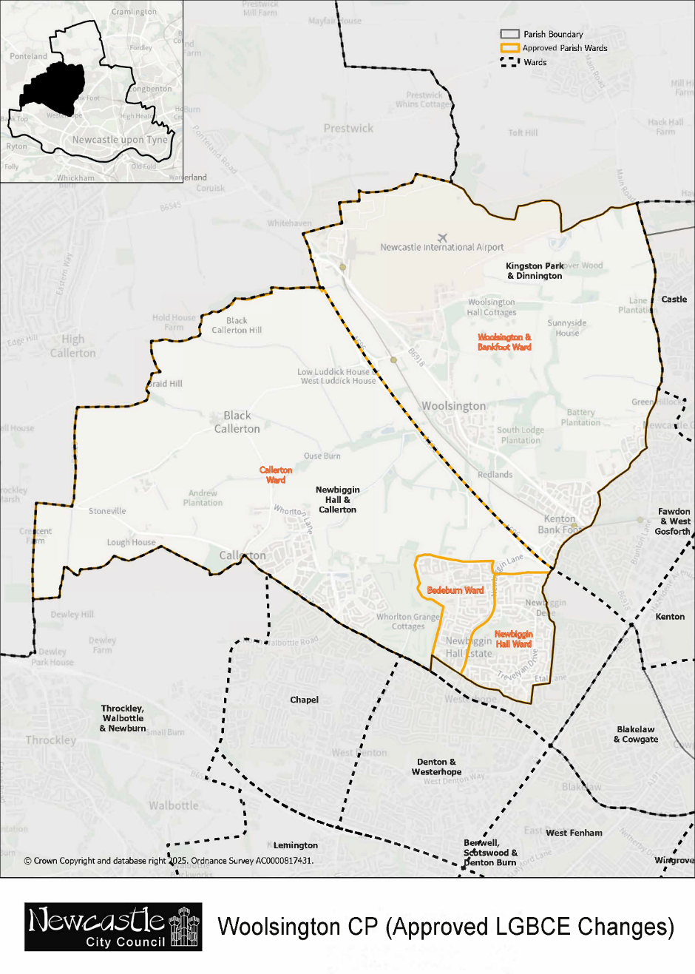
Figure 9 - Map of parish of Woolsington following approved LGBCE changes

Conclusion
  - The Council has undertaken this Community Governance Review having regard to the statutory criteria contained within LGPIHA 2007 and the representations received during the initial consultation period.
  - The Draft Recommendations seek to ensure that community governance arrangements across the six parished areas continue to reflect local identities and interests, provide effective and convenient local government and maintain appropriate arrangements for community representation and engagement.
  - In preparing these Draft Recommendations, the Council has concluded that changes are justified in Brunswick, Hazlerigg, North Gosforth and Woolsington, whilst the existing arrangements in Blakelaw and North Fenham and Dinnington are considered to remain appropriate.
  - These Draft Recommendations do not represent the final outcome of the Review. The Council welcomes comments on any aspect of the recommendations. All representations received during the next stage of consultation will be carefully considered before Final Recommendations are prepared and submitted to Council for determination. The second stage of public consultation shall commence on 2 November 2026 and conclude on 30 November 2026. Following consideration of all representations received, the Council will publish its Final Recommendations and, where appropriate, implement any changes through a Reorganisation of Community Governance Order.

Appendix A – Schedule of Consultation Responses
Consultee capacity | Parish area represented | Comment
Blakelaw and North Fenham Parish Council | Blakelaw and North Fenham | The community council have agreed not to go ahead with extending the boundaries of the community council and would happily consider reducing the number of community councillors on the board to 8/9.
Parish Councillor | Blakelaw and North Fenham | Question: Do you agree with the Council's proposed changes to Blakelaw and North Fenham Parish?  Response: There are no preposed changes  Question: Do you have any alternative suggestions or comments regarding the proposed arrangements? (optional)  Response: My concern is that the grants given to community groups are capped at £500. Not many groups request grants so £20000 was carried over last year. Yet there are a lot of needs in the area.
Resident | Blakelaw and North Fenham | Question: Do you agree with the Council's proposed changes to Blakelaw and North Fenham Parish?  Response: Yes, I agree with the proposed changes. They appear sensible for improving local community governance, representation, and the overall management of services within the Blakelaw and North Fenham parish area.
Brunswick Parish Council | Brunswick | Brunswick Parish Council confirms support for the CGR as originally requested by Hazlerigg Parish Council and supported by this Council.
Resident | Brunswick | No. I do not agree with the proposed transfer of Havannah Park from Brunswick Parish to Hazlerigg Parish. Whilst I recognise that residents of Havannah Park have expressed a clear preference to be within Hazlerigg may reflect local community wishes, I believe it is essential to consider the wider implications of this boundary change on the remaining Brunswick community.  I have no objection in principle to the pavilion, playing field and allotment site being included within Hazlerigg Parish if that provides a coherent boundary and reflects the wishes of the residents directly affected.  My principal concerns with the proposed changes are:  Impact on Brunswick Parish’s viability  The proposed transfer would reduce Brunswick’s electorate from approximately 1,502 to around 710 residents which more than halving its population. The Council's consultation document itself identifies this substantial reduction and acknowledges that a change to the composition of a parish could affect the precept paid by residents. This significant reduction raises concerns about the long-term financial sustainability of Brunswick Parish Council, particularly given the current insignificant precept currently received by the Brunswick parish council (down from £12 in previous years).  A smaller electorate could limit the Parish’s income, potentially impairing its ability to support local initiatives, maintain community projects, and respond to future needs. There is also a possible tension between maintaining an effective level of parish activity and keeping the financial burden on the remaining residents reasonable. I would therefore like the Council to consider whether the proposed boundary could leave Brunswick with insufficient financial capacity or alternatively create pressure for a higher precept on the residents who remain.  The Council therefore needs to consider not only whether the proposed boundary reflects the identity of Havannah Park residents, but also whether the resulting parish will continue to be a viable and effective community for the residents who remain in Brunswick.  Financial and governance implications  It is crucial that the Council provides a clear assessment of the expected reduction in annual precept income as a result of this boundary change. Furthermore, I urge the Council to consider whether a smaller parish electorate might lead to increased precept demands on the remaining residents to sustain services, potentially creating financial strain and affecting community cohesion.  Long term community identity and effectiveness  Reducing Brunswick’s size and population may weaken its sense of community identity and diminish its capacity to function as a sustainable, effective local authority. I recommend that the Council evaluates whether the new boundary arrangements will continue to serve the needs of residents in the coming years, not just immediately after the change.  I would ask the Council to provide a clear assessment of the likely financial impact of reducing the Brunswick electorate from 1,502 to 710. For example:  - What is the projected reduction in precept income due to this boundary change?  - Has the Council evaluated the potential for future precept increases on remaining Brunswick residents?  - What assessments have been undertaken regarding Brunswick’s ability to remain a viable and active community after the transfer?  - Could alternative boundary arrangements or review mechanisms mitigate adverse effects while respecting Havannah Park residents' preferences?  I would also ask the Council to consider the longer-term implications rather than looking only at the current position. A reduction of more than half the electorate is a substantial structural change to the parish. It is important that the new arrangement remains appropriate not just immediately following the review, but over the coming years. The Council should also consider what the proposed change means for the identity of the remaining Brunswick community.  Although Havannah Park residents may reasonably identify with Hazlerigg, Brunswick village will continue to have its own established community, history and local interests. The review should therefore consider whether reducing Brunswick so significantly could weaken its sense of identity or its ability to function as a distinct and sustainable parish.  I would also welcome clarification of whether the Council has considered alternative arrangements which could recognise the expressed preference of Havannah Park residents while limiting the adverse financial and organisational consequences for Brunswick. For example, could the Council consider a staged approach, or could it introduce a formal review after a defined period to assess the actual effect of the boundary change on Brunswick?  A subsequent review could consider:  • the size and composition of the Brunswick electorate  • the financial position of the Parish Council and the effect on the precept  • the ability of the Parish Council to continue supporting local projects and priorities  • whether residents continue to regard Brunswick as an effective and meaningful community  • whether the new boundary is working as intended for both Brunswick and Hazlerigg  I believe this would provide an important safeguard. It would recognise the views of Havannah Park residents while also ensuring that the consequences for the remaining Brunswick residents are not overlooked.  I therefore ask the Council to recognise that there are two legitimate considerations in this proposal.  - The wishes of Havannah Park residents to be part of Hazlerigg should be properly recognised, and I do not object in principle to the development, pavilion, playing field and allotment site being transferred to Hazlerigg.  - At the same time, the interests of the residents remaining within Brunswick must also be properly considered. Reducing the electorate from 1,502 to 710 is a substantial change which could have significant consequences for the financial viability, identity and effectiveness of Brunswick Parish.  While I support respecting the expressed wishes of Havannah Park residents to join Hazlerigg, I emphasize that the broader implications for Brunswick’s sustainability must be carefully considered. A balanced approach, one that ensures both communities’ interests are protected which will be essential to achieving governance arrangements that are fair, effective, and sustainable.
Hazlerigg Parish Council | Hazlerigg | Hazlerigg Parish Council have met this evening and discussed the proposals.  The Parish Council have asked me to email you to say that they support all of the draft poposals for their area.
Parish Councillor | Hazlerigg | We are yet to submit our formal response to the CGR but were surprised to see proposals for bringing Brunswick allotments into Hazlerigg parish.  These allotments are hugely problematic and both Brunswick Parish Council and Newcastle City Council have failed to take any action to address the ongoing issues.  We are therefore strongly against these problem allotments being brought within our parish.
North Gosforth Parish Council | North Gosforth | The Parish Council confirms its support for the CGR as originally submitted by this Parish Council
Resident | North Gosforth | Question: Do you agree with the Council's proposed changes to North Gosforth Parish?  Response: Yes
Woolsington Parish Council | Woolsington | Question: Do you agree with the Council's proposed changes to Woolsington Parish?  Response: The City Council recommends the following Ward representation changes:  Woolsington & Bank Foot from 2 to 3 Members  Newbiggin Hall from 5 to 4  Bedeburn from 4 to 3  Callerton from 1 to 2  The proposal reflects the current position well.  However, further Housing Development, new services and roads are planned, particularly for Callerton, over the next 5 years. This will lead to a phased, but significant, growth in population and in the electorate.  For these reasons, Woolsington Parish Council believes that a representation of 3 Members per Ward would be more sustainable in the longer term.  Question: Do you have any alternative suggestions or comments regarding the proposed arrangements? (optional)  Response: As recommended in the answer to Question 1, WPC suggests that the 4 Wards have a representation of 3 Members each, that is:  Woolsington & Bank Foot from the current 2 to 3 Members  Newbiggin Hall from 5 to 3  Bedeburn from 4 to 3  Callerton from 1 to 3  This would give the Parish Council a more balanced representation moving forward.  Additionally, it would reflect local identity with greater accuracy and help maintain current standards in governance.
Parish councillor/ Woolsington parish Council | Woolsington | - What is to be found in the Parish: a brief description of key features  - 17.2 sq km of rural, semi-rural and urban areas  - Approx. 4km of the River Ouse Burn flows through the Parish, plus 13 km of tributaries, making it a key part of the catchment’s health  - 4x Primary Schools, 1x Secondary School  - 1x International Airport; associated infrastructure and a Training Academy  - Metro link to the Airport, City centre + coast; 3x Metro Stations (Bank Foot, Callerton Parkway, Airport)  - A696 dual carriage way connecting the A1 to the Airport and to the North  - Kingston Park Stadium, home of Newcastle Red Bulls (Rugby)  - Leisure United Sports Centre at Bullocksteads  - Woolsington Park: Grade II listed building and listed parkland  - Westerhope Golf Course  - 4x Hotels (Double Tree, Brittania, Novotel, Premier Inn)  - 4x Public Houses (Twin Farms, The Wheatsheaf, The Poacher’s Cottage, The Jingling Gate)  - Redburn Industrial Estate  2. Current and planned changes to the Demographics  Since the last review in 2018 Woolsington Parish has seen considerable growth and has had to embrace many challenges. Most of these are directly associated with:  - Airport business development: Airview Park, Fastned (ultra-rapid EV charging hub), terminal extension and a record increase in passenger numbers. There is further significant growth forecast in the NIA Masterplan 2040.  - Large scale Housing Development with new housing estates built in Bank Foot (Woolsington Grange, Kenton Bank Mill, Kenton Bank Hall) and Middle Callerton. This is resulting in an estimated increase of 1,000 houses.  - The opening of Callerton Academy in Newbiggin Hall.  - There are housing plans for Bank Foot (Foxfields/ Kenton Bank Meadows), Woolsington (Kingston Village), and Upper Callerton which will result in an increase of an estimated 2,500 houses.  - The projected population increase is forecasted at 40% across the Parish from the figures produced in 2018.  3. Impact of change in demography on the Parish Council  The impact of this growth has resulted in the need for very careful and considered planning in the deployment of Parish CIL funding. This is largely to assist in the improvement and maintenance of physical, social and green infrastructure, all of which is needed to support the cumulative impact of new development in the Parish.  Extensive community surveys were carried out in some Wards to determine the public perception of priorities for the Parish Council’s 15% CIL entitlement. Results were:  - Protect open green and blue spaces and provide better access for the community  - Remove litter  - Road safety  - Recreation & leisure  - Community events  4. Parish Projects funded by CIL  Listed below are some of the projects managed by Woolsington Parish Council. Many are undertaken in partnership with other agencies across the City. These multi-agency projects have benefits that naturally extend beyond the Parish boundary.  They are currently all live and active and have indefinite time periods to run.  Plans to introduce these projects were based on City Council policy and responses to the Community questionnaires received by WPC.  They were categorised and prioritised according to the level of public interest and implementation plans have been scheduled over several years.  4.1 The Upper Ouse Burn Sub Catchment Partnership  - Working with various Agencies, namely Tyne Rivers Trust, The Ouse Burn Way (Newcastle’s Green Link), the Environment Agency and the City Council on improving the river quality and natural habitat in the Upper Ouse Burn (Callerton & Woolsington Parish Wards)  - The Parish Ponds site in Woolsington hosts one of the 6 Key Stations of the Smart Rivers project along the River Ouse Burn. Consequently, the work undertaken by WPC on habitat and water quality in both the Ponds & River plays an active role in this City-wide initiative  4.2 The Parish Ponds  - Managed in partnership with Landowners (Taylor Wimpey & Persimmon Homes) delivering habitat and site improvements; making the Nature Area more accessible and creating a better environment for people & wildlife to co-exist  - The project involves many stakeholders: Tyne Rivers Trust, Natural History Society of Northumbria, The Ouse Burn Way, Northumbria Water, The Environmental Agency, Northumbria Police, City Council and Newcastle Airport (the Parish Ponds site is located across the Callerton & Woolsington Wards).  - Light site maintenance and litter collection & disposal is regularly undertaken by a contract landscaper  - This is now a valued asset for the City and has become a popular recreational destination (Note the forthcoming publication - 111 Must see places from the T&W Metro)  4.3 Forever 7: Archie’s Nature Trail - a City-wide Asset  This is a long-term community project which needs careful planning for sustainability. The trail was created in partnership with Newcastle City Council, the Landowners (Taylor Wimpey & Persimmon Homes) at the Parish Ponds (Callerton & Woolsington Wards). The nature trail is to celebrate and commemorate the life of Archie York, who tragically lost his life aged 7 in the Benwell house explosion in October 2024. It officially opened on 29 May 2026, on what would have been Archie’s 9th birthday.  4.4 Area Biodiversity Project  4.4.1 Ward based activity  A Parish-wide project was established in 2019 (across all Wards) for improving quality of life for people & nature. A variety of community-based schemes have been introduced.  Common local activity includes: planting and maintaining flower beds, planting spring bulbs, native plants and wildflowers, trees, building insect hotels, creating wildlife corridors.  This project is planned and managed by the Parish Council, prioritised according to budget and the maintenance of all activity is regularly scrutinised.  Matched funding and donations have been received from the Northumbria Water Group, Newcastle Airport, Developers and other commercial organisations.  The large flower bed outside Sovereign Lodge Residential Care Home on Newbiggin Lane (Newbiggin Hall Ward) has become a landmark feature and is regularly maintained by a local contract landscaper.  4.4.2 Schools  The Parish Council works in partnership with the 4x primary schools in the Newbiggin Hall and Bedeburn Wards. This is not a grant-based scheme. Projects include joint planning with staff on outdoor learning and biodiversity, which are all now part of the education curriculum. Work includes the introduction of nature Ttails, wildflower belts and edible gardens.  4.5 Community Events  Community engagement and community events are at the heart of the Parish Council principles for its Biodiversity Project work.  It is organised with landowners, local businesses and agencies and customised according to individual circumstances.  - At the Parish Ponds - hosted by the Natural History Society of Northumbria & The Ouseburn Way  These educational events are suitable for all ages e.g.  - Dead Hedging  - Pond Dipping  - Wildflower management  - Bat nights  - Butterflies & Moths  - Dragonflies & Damselflies  - Fungi & Mushrooms  - In Abbotswood, Woolsington  - Wildflower management  - Bulb planting  - The Parkrun in Callerton  A weekly event being organised by Parkrun, the Parish Council and community volunteers. Funded and managed in partnership with the Landowners (Taylor Wimpey & Persimmon Homes and Northumberland Estates). It is to take places on the bridlepaths of Upper Callerton and the Parish Ponds.  - Litter Picking (across all Wards)  These are spontaneous events and are organised on a needs basis.  4.6 Newcastle International Airport (NIA/ WPC) Trust  A trust agreement was established in 2022 between the Parish Council and the Airport in order to invest funding in habitat improvements and in the establishment & maintenance of wildlife corridors. The location for this is Abbotswood (Woolsington Ward) which is owned by NIA but can be accessed by the community.  This project is also aimed at supporting NIA in delivering its Biodiversity Net Gain targets in the City & beyond.  WPC Members for Woolsington & Bank Foot also meet with Airport Management on a regular basis to discuss plans for growth and potential impact on the local community and infrastructure. This is part of the pre-planning process mentioned below.  WPC is also represented at the Airport Consultative Committee and currently provides the Deputy Chair.  4.7 Post construction assessment and tree protection  Members work in partnership with local developers and Newcastle Airport on the monitoring of S106 agreements, which includes support for delivering Biodiversity Net Gain targets. The prime objective is to work together to ensure that all committed outcomes are delivered for the benefit of new home owners and the wider community.  Attention is paid to landscaping, planting of trees and tree maintenance.  Woolsington Parish has a large population of trees, with many veteran trees, which are protected by individual and blanket TPO policies. The Parish Council works with the City Council to ensure their protection, and that the correct procedure for maintenance/removal is followed, across all Wards.  4.8 Road Safety  The Parish Council works in partnership with both Newcastle City Council and Developers as increased development results in increased population and the inevitable pressures on road infrastructure.  Introduction of street signs, road safety signs, dropped kerbs, monitoring of speed limits, and problems associated with car parking (particularly Airport-related traffic across the Woolsington & Bank Foot Ward)  Members have also worked with the City Council on instigating road resurfacing repairs in a car park in Lowbiggin (Bedeburn Ward) and resurfacing a stretch of Trevelyan Drive (Newbiggin Hall Ward)  4.9 Pre-Planning  Members respond to an average of 25-30 Planning Applications annually, often working with Developers and Businesses (Airport) at the pre-planning stage.  This is primarily to contribute and advise on community related issues, infrastructure, visual impact and how to partner on Biodiversity Net Gain targets (a corporate activity across all Wards).  4.10 Ongoing support for the local Community: Health & wellbeing  The Parish Council has been very active in supporting its local communities, with a particular focus on children, families and the wider wellbeing of residents.  4.10.1 Children and families  Support has been provided to D2 Children’s Services (Bedeburn & Newbiggin Hall)), along with other charitable contributions, ensuring that children’s health and wellbeing remain at the heart of the work WPC undertakes. The aim is to help ensure that children have access to sporting activities, days out and seasonal pastimes that provide positive experiences and opportunities for them to enjoy.  Members have also provided library books to local primary schools to support learning and encourage children’s interest in reading, helping to give young people the resources and opportunities they need to thrive.  In addition, WPC has supported spring bulb planting across the Parish, helping to improve and enhance the local environment and create more attractive spaces for residents to enjoy.  These activities demonstrate that the Parish Council’s commitment to investing in its community — not just through individual projects, but through ongoing support for children, families, education, health and wellbeing, and the environment  4.10.2 The Defibrillator Project  6x external defibrillators have been installed across the Parish, in partnership with The NHS Circuit, St Wilfrid’s Church and local businesses.  Members of the Parish Council perform status checks on each machine every 3 months and record details on The Circuit website.  Annual Maintenance of each machine and replacement of any parts is carried out by a local contract electrician.  5. Potential changes in current arrangements to provide effective and convenient local governance  Taking into account the impact of growth on the Parish demographics (current and future) and the resulting project work undertaken by Parish Council, Members propose that some governance arrangements need to be refreshed.  From May 2027 the Parish Ward Member representation will stand at:  - Newbiggin Hall x4  - Bedeburn x3  - Callerton x2  - Woolsington & Bank Foot x3  However, growth and the requirement for local services and support have increased significantly since the last review in 2018.  Therefore, the Parish Council believes that this representation does not reflect the change in demographics in the Callerton Ward and is now disproportionate to the number of houses & population in this area.  A more accurate proportional representation to provide effective and convenient local governance in Woolsington Parish would be:  - Newbiggin Hall x4  - Bedeburn x3  - Callerton x3  - Woolsington & Bank Foot x2
Resident | Woolsington | Wooolsington Parish Council and its stakeholders are doing a fantastic job at the Parish Ponds. Restoring the site into a Nature Area which has united the whole community.  Future proofing the site for people and wildlife.  Forever 7: Archie`s Nature Trail is not only a magnificent tribute to Archie York and his family but is also becoming a `must visit place` for the entire City.  I notice from the consultation document that the Ponds site has been moved into Callerton. Will you please ensure that this does not disrupt the progress made with this wonderful project and that the Parish Ward of Callerton is sufficiently equipped in representation and budget to ensure that this happens.
Resident | Woolsington | Woolsington Parish Council currently do fantastic work for the community, so any changes should make sure this is not undermined.  In particular, the Parish Council have been the driving force behind the Parish Ponds Community Project which has had a massive community and environmental impact.  I notice the Parish Ponds will fall under the Callerton Ward rather than Woolsington and Bank Foot Ward as it currently stands- any changes should ensure that the Parish council members continue to have the ability to drive this work forward, a significant community priority, without disrupting the projects aims, plans and funding to do this. Here is a small snapshot of what this work continues to deliver:  - Biodiversity and environmental improvements: due to the ongoing work of this project there has been a noticeable return of species, diversity of wildflowers and action taken on invasive species - the Ponds are now seen as a landmark and unique part of the Ouse Burn catchment, and as such, continues to attract visitors from across the area  - Community building and involvement - the Parish council have instigated and continue to lead a Community group to deliver improvements at the site - encouraging volunteers, community spirit and education in the local area and across the region- people are coming from far and wide  - Archie’s Nature Trail - Another landmark piece of work at the Ponds, creation of a nature trail in memory of Archie Yorke, encouraging children’s education and wellbeing in nature, including school visits facilitated by the Parish Council - this must be protected both for Archie’s memory plus the legacy this brings  - The Parish Council have been pivotal in protecting the site and working with landowners and housing developers to ensure the area is protected and enhanced for the local community - now and into the future. This work is not complete and must continue to protect this vital asset  - Anti-social behaviour - all the work done as part of the protect has included tackling anti-social behaviour- trying to engage local communities and ensure the area is safe and can be used by all. The more work we do, the less anti-social behaviour there will be, and the more those isolated community members will feel part of the area  - Park Run - an exciting development is future plans for a Park Run, led by a parish council member. This has proved extremely popular with the local community, with lots of people wanting to support and be involved. This can only happen with the Parish Councils continued support, by the members of the council who take a visible and active role in community engagement.  I would particularly like to call out the work done by John Littleton and Joanne Couchman who have put so much effort into getting this project to where it is, as well as Lilian McGuinness for her continued involvement. Without their commitment and enthusiasm, this flagship community project would not be where it is.  In a world where we need community more than ever, we cannot let these changes have a detrimental impact on the fantastic work that these members of the council currently lead and the benefits that the Parish Ponds bring both environmentally and socially across the region.
Resident | Woolsington | As Archie’s Mother, I feel as if Woolsington council have had a great impact on myself and my family for helping arrange ‘Archie’s forever 7 nature trail’. Our little family used to go up on family walks around the area, where Archie’s trail is based. My worry is if funding isnt available, no one would be able to look after the walk and make it safe by maintaining the area, for the community to love and enjoy the walk as much as us. Archies school recently went up on a trip, hosted by John, Joanne and Cal. Teaching the children all about the great outdoors, ideally I’d like other schools to go up on the trail so they can enjoy the trail, like Archie’s school friends did. Archie’s walk is a long lasting tribute to us, and no one better to look after it, than Woolsington parish council.
Resident | Woolsington | Question: Do you agree with the Council's proposed changes to Woolsington Parish?  Response: No  Question: Do you have any alternative suggestions or comments regarding the proposed arrangements? (optional)  Response: Callerton should have 3 Members and Woolsington & Bank Foot 2

Appendix B – National Association of Local Councils (NALC) Guidance on Parish Councillor Numbers
Electorate | Recommended Number of Councillors
Up to 900 | 7
1,400 | 8
2,000 | 9
2,700 | 10
3,500 | 11
4,400 | 12
5,400 | 13
6,500 | 14
7,700 | 15
9,000 | 16
10,400 | 17
11,900 | 18
13,500 | 19
15,200 | 20
17,000 | 21
18,900 | 22
20,900 | 23
23,000 | 24
Over 23,000 | 25

